PEOPLE COUNTER SYSTEM

**Abstract**

This is a project report on “**PEOPLE COUNTING TECHNOLOGY**”. During the making/developing of this project we explored new ideas and functionality behind the working of a notepad.

This project is the output of our planning, schedule, programming skill and the hard work, and this report reflects our steps taken at various levels of programming skill, planning and schedule.

We have learnt a lot during this project and liked the improvement in our testing skills and deep concept related to these kinds of projects.

Our project is **PEOPLE COUNTER**. Thisis a sensor based micro controller connected technology sending information to a website based data on cloud using MYSQL application which helps people to find and buy real time database of different areas,locations and rooms in a building space sever using internet. It is useful in the way that it makes an easier way to interact within data analysis of people in a building.

In this application we have basically 2 modules. The first module includes the space and location module.

The customer has to register for any enquiry related to location . The unregistered person can’t access this application. The registered customer can view details of areas and he can buy the database of his choice and need. He has to pay the price of people counter analytics database.

The admin module contains the access of admin on the application. The admin can change everything in the application. He has the ability to add, delete, and update any information regarding the locations.

**Preface**

Learning comes from doing. To learn something one has to go through Practical conditions. Recognizing this fact, the University has made it essential for **INFORMATION TECHNOLOGY (IT )** students to undergo working on this project. During this period, the student learns about the functioning of the organization and the actual business environment. Also this training helps the student how to implement the theoretical knowledge into practical life, in our day to day life.

**PROJECT DESCRIPTION**

In today’s busy world, people are so busy to be related to risk on various factors such as crowded places, traffic, safety issues as well as how busy or free a location space is working in a real time environment . And Here’s a technology that is so fast that anyone can do anything by just sitting in a room. The internet is the way that helps a person in all aspects. If someone wishes to buy and view databases on server for any space using its location to buy analytics details of features such as safety , traffic as well as facilities and the main purpose of how much people are in real time present on a location or any place particularly requested information online with the help of internet.

Today there are very least organizations which are manual. Everything is going to be computerized and online whether it is banking, advertising or shopping, and travelling etc. We are trying to help people to make their life easier by proving online information of people counting technology.

The project’s home page includes the registration link. The registered users can login to their account for their queries or buy new clothes. And the unregistered users have first to register. The registration can be done by following the sign up link.

COMPONENTS OF THE PROJECTS

1. **How to Login**

In this module, the user will enter his username and password to view and buy latest products. There will be 2 types of users Administrator/Customer

1. **How to be a member of this application**

In this site, the candidate can join this application, if he is not a member yet by pressing sign up link .User should provide some details that are asked to join.

1. **How to view the location details**

Any space or room can be searched by selecting the building no. which the user wish to view or buy data analytics for.

**4. How to give the Order**

First, the user has to login and then he will visit on view products page.

There he will select the room location details he wants to buy and click on show product

detail and he can purchase that details.

All the details regarding that selected results of counter anaylsis will be shown to the user text

field.

1. **How to pay money**

The user can pay through debit or credit cards using paypal sandbox technology.

REQUIREMENT ANALYSIS

**Hardware Requirements**

|  |  |
| --- | --- |
| **Number** | **Description** |
| 1 | Intel core ,WIN xp/7/vista |
| 2 | 320 MB RAM |

**Software Requirements**

|  |  |
| --- | --- |
| **Number** | **Description** |
| 1 | Windows XP –7 |
| 2 | Php 5.1 |
| 3 | MySql |
| 4 | IIS server/ WAMPSERVER |
| 5 | HTML/Dhtml/Ajax/JavaScript/Css/  flash 8 |

**MODULES**

**Login Module** –In this module user can enter the application by providing username and password and start shopping.

**Admin Module** – Admin Can add, modify the latest details of new areas and locations as well as particular spaces in a building.

**Join Module** – In this module user can become a part of the site by providing some necessary information for example first name , last name ,password ,confirmation password ,email and other details .

**purchase Module –** The customer can view and buy latest models of databases on real time server connected with micro controller sensors operated under aurdino.

**Administrator** – **Can add, modify, delete the details** .

**INTRODUCTION TO TOOLS**

**FRONT-END/BACK-END**

**Front-End: Web Pages using PHP, HTML , JavaScript.**

**Back-End: MYSQL**

**Front End:**

* **HTML** –It is used to generate web page . HTML, an initialism of Hypertext Markup Language, is the predominant [markup language](http://en.wikipedia.org/wiki/Markup_language) for [web pages](http://en.wikipedia.org/wiki/Web_page). It provides a means to describe the structure of text-based information in a document — by denoting certain text as headings, paragraphs, lists, and so on.

* **JAVASCRIPT** – It is used for checking User information before sending to JavaScript is a [scripting language](http://en.wikipedia.org/wiki/Scripting_language) most often used for [client-side](http://en.wikipedia.org/wiki/Client-side) web development. It is a [dynamic](http://en.wikipedia.org/wiki/Dynamic_language), [weakly typed](http://en.wikipedia.org/wiki/Weak_typing), [prototype-based](http://en.wikipedia.org/wiki/Prototype-based_programming) language with [first-class functions](http://en.wikipedia.org/wiki/First-class_function). Currently, "JavaScript" is an implementation of the [ECMAScript](http://en.wikipedia.org/wiki/ECMAScript) standard.

**Backend:**

* **PHP:-** Php is a technology that lets you mix regular, static HTML with dynamically-generated HTML. Many Web pages that are built by CGI programs are mostly static, with the dynamic part limited to a few small locations. But most CGI variations, including servlets, make you generate the entire page via your program, even though most of it is always the same.
* **IIS SERVER** /XAMP- Apache is a [web container](http://en.wikipedia.org/wiki/Web_container), or [application server](http://en.wikipedia.org/wiki/Application_server) developed at the [Apache Software Foundation](http://en.wikipedia.org/wiki/Apache_Software_Foundation) (ASF).It adds tools for configuration and management but can also be configured by editing configuration files that are normally [XML](http://en.wikipedia.org/wiki/XML)-formatted. Apache includes its own internal [HTTP](http://en.wikipedia.org/wiki/Hypertext_Transfer_Protocol) server.

**Admin Profile**

**It works as a connectivity to add information to the backend database using php and javascript connecting background information to be added on the server and then represented on the HTML page.**

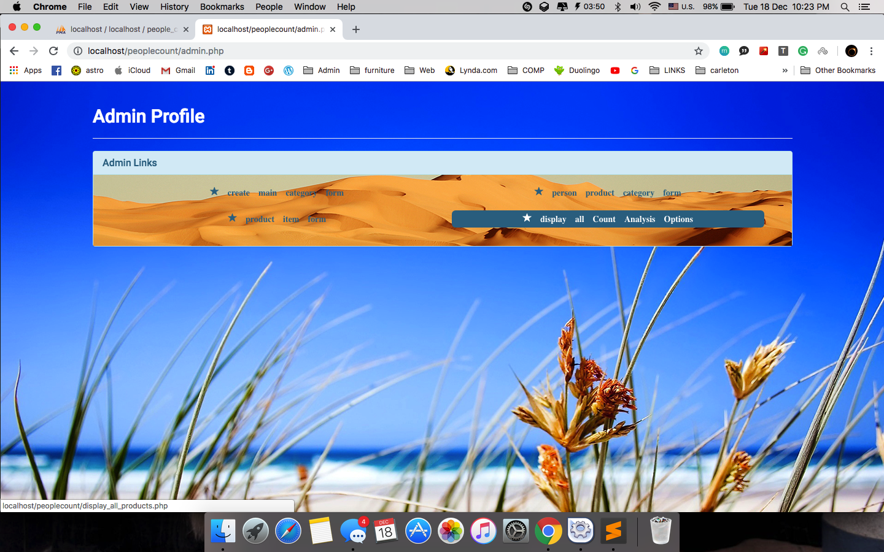

ADMIN PAGE FORM

IN this page room locations can be added

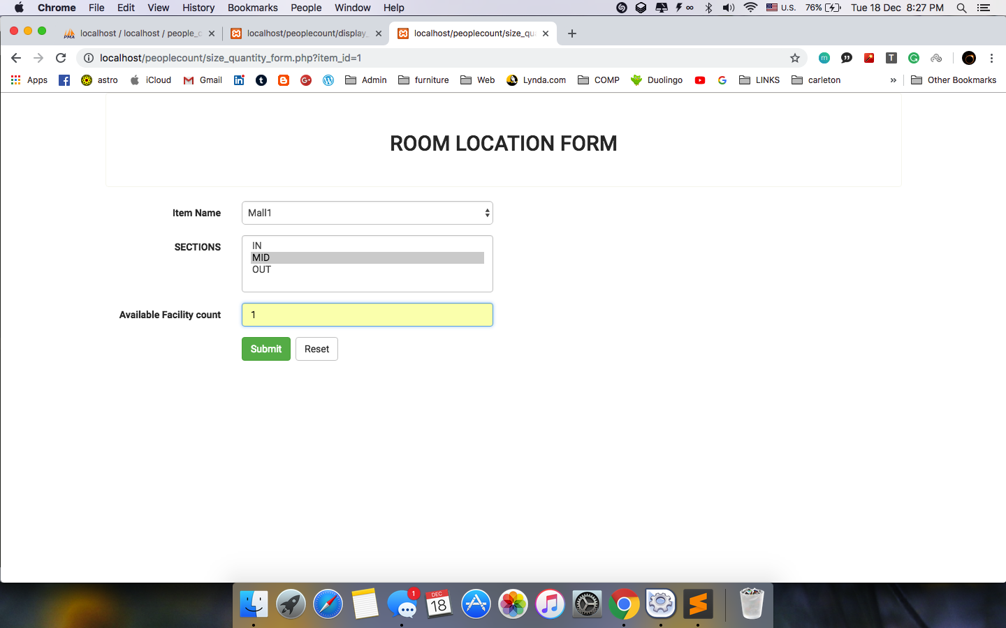

admin can add database details to create and link the building as well as room location as main key constraint to the foreign key which holds the categories of all elements on a drop down list of Main functional location selected by user on HTML page

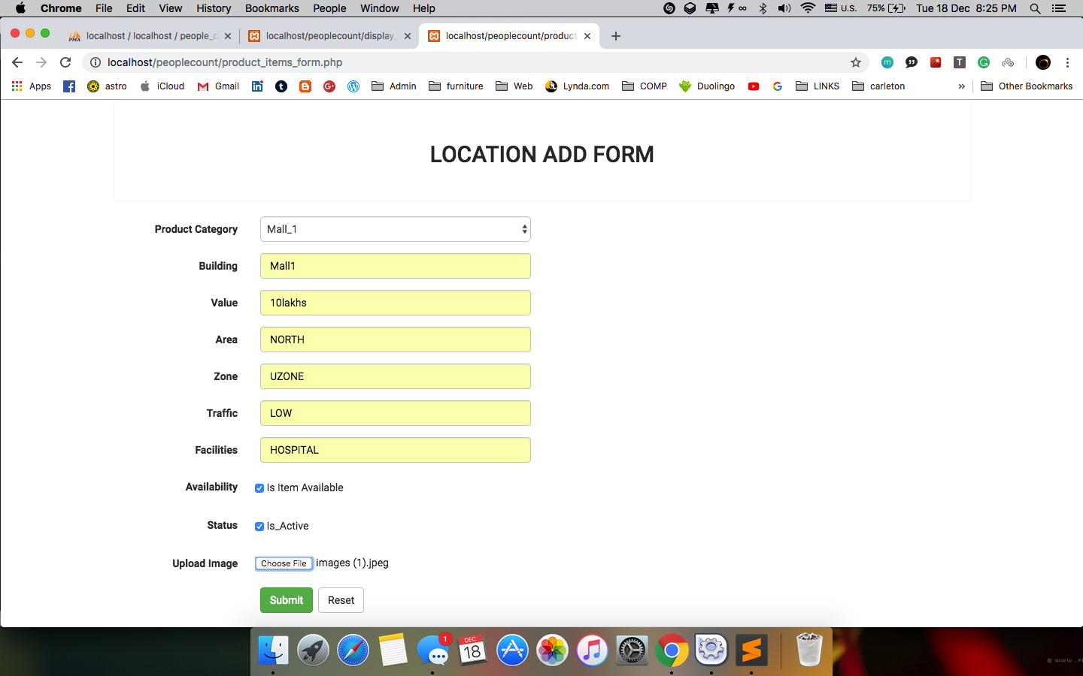

The layout of the main page which lands when a user or admin connects server to directed on the webpage showing all the components and features of details of the webpage about the working of people counter technology.

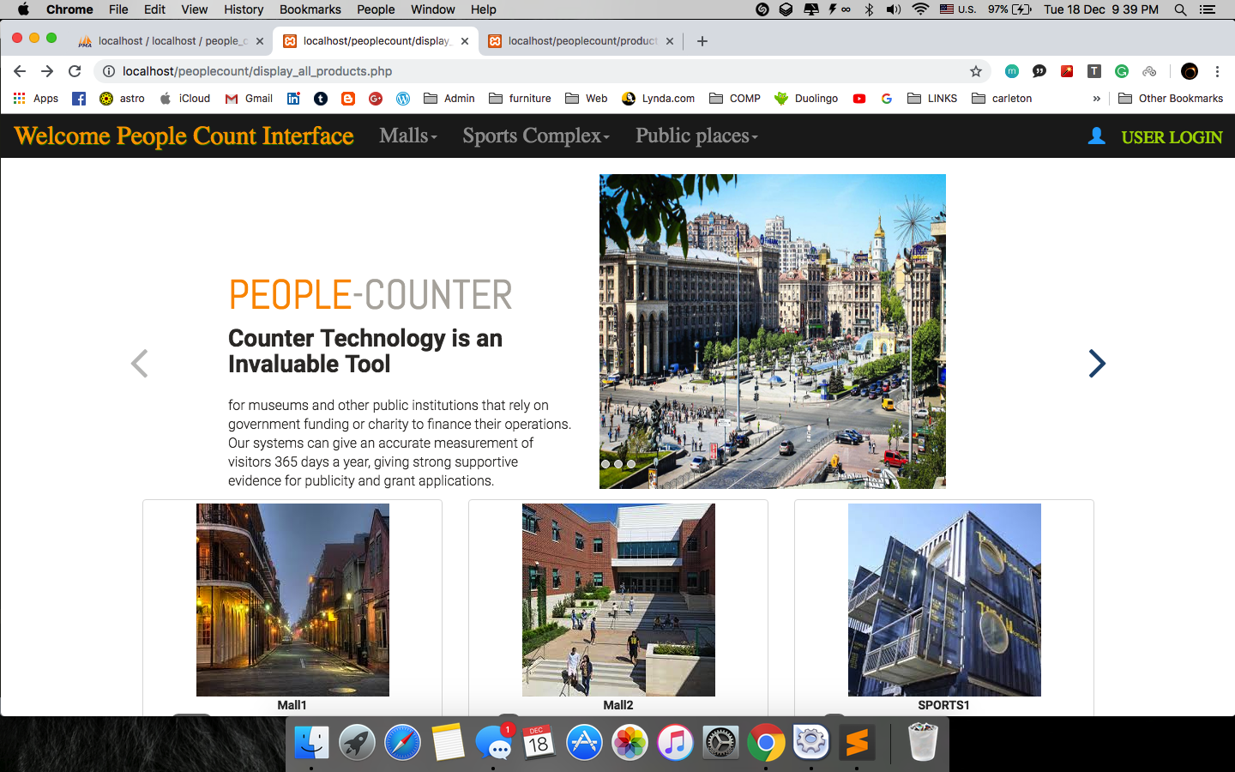

Layout shows the slider tag for photographic representation as well as the details of People Counter with all the available options to be selected for required information

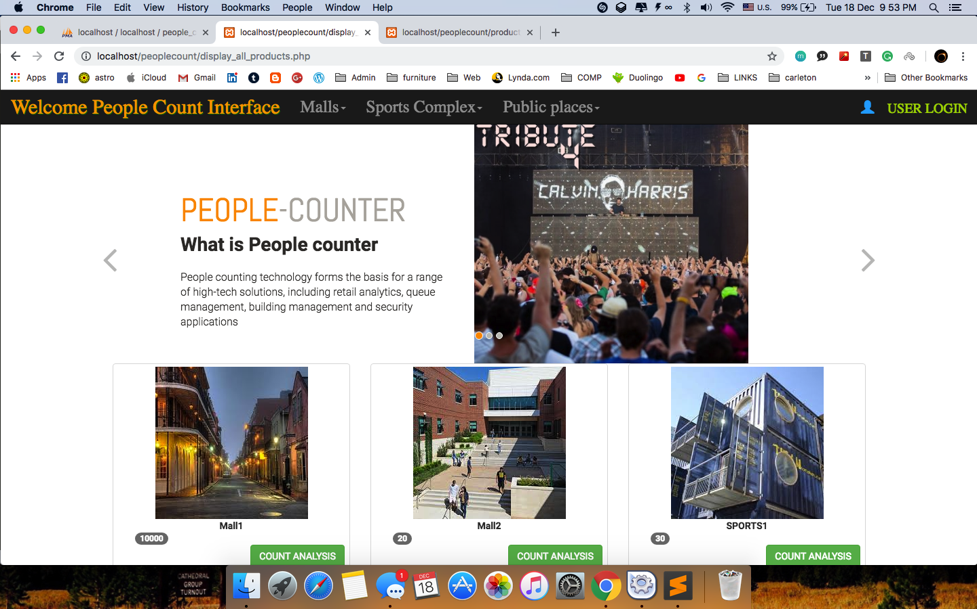

Database representation for the available details of the buildings which are added by the admin on given details from any location or building or government organization or public place

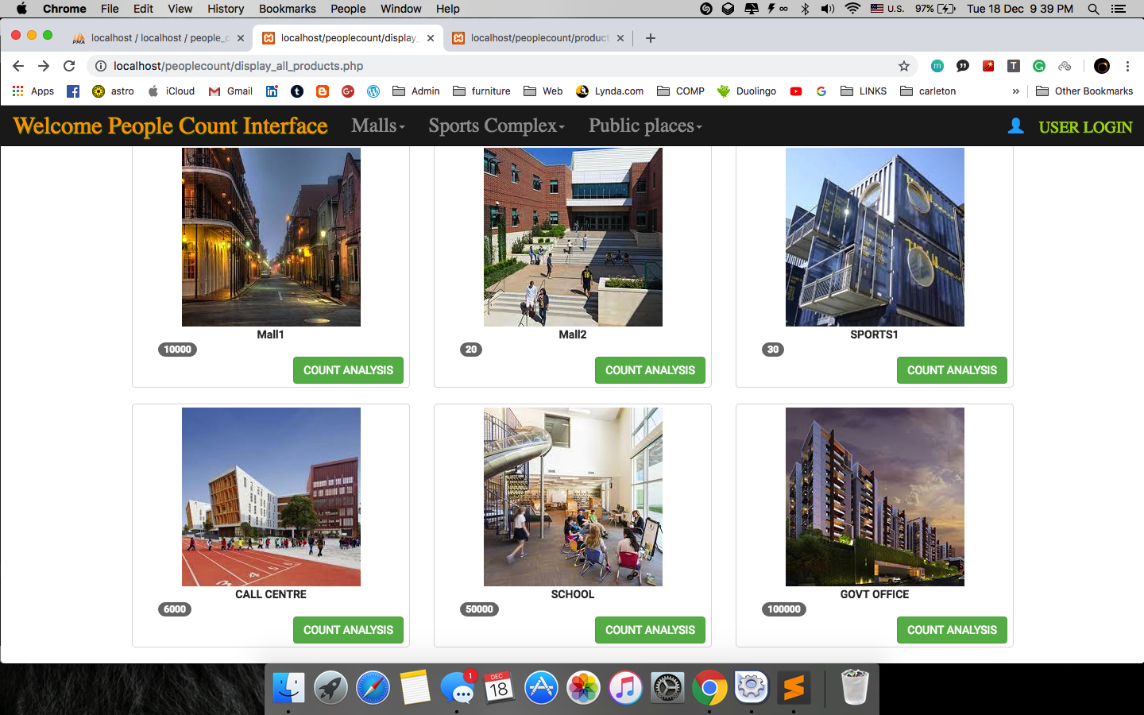

shows available options for a particular category of

space such as any mall under malls, sports place under sports complex etc and this can be modified and any details could be adjusted within real time information updated by admin can be done in future.

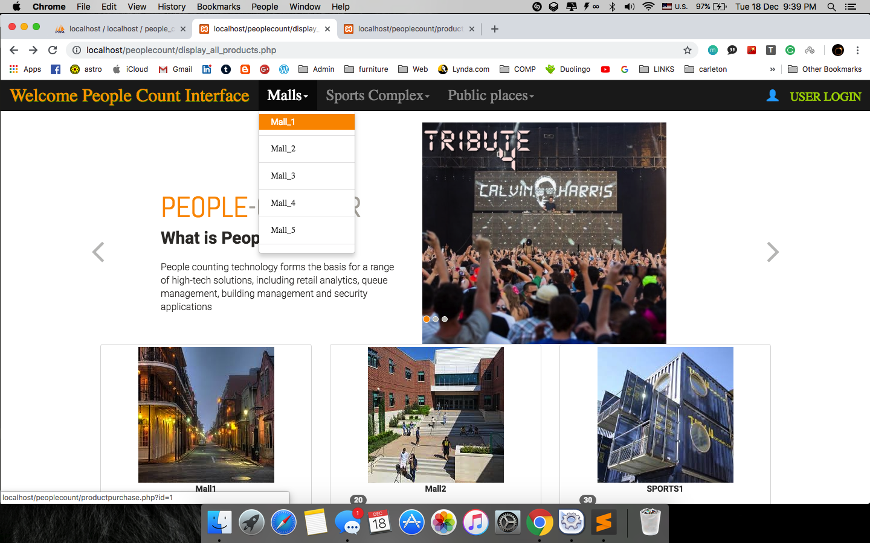

structure of data base management system as a layout used which shows the keys and constraints as well features of each of the data tables contacting particular information for each HTML page forwarding data in real time actions.

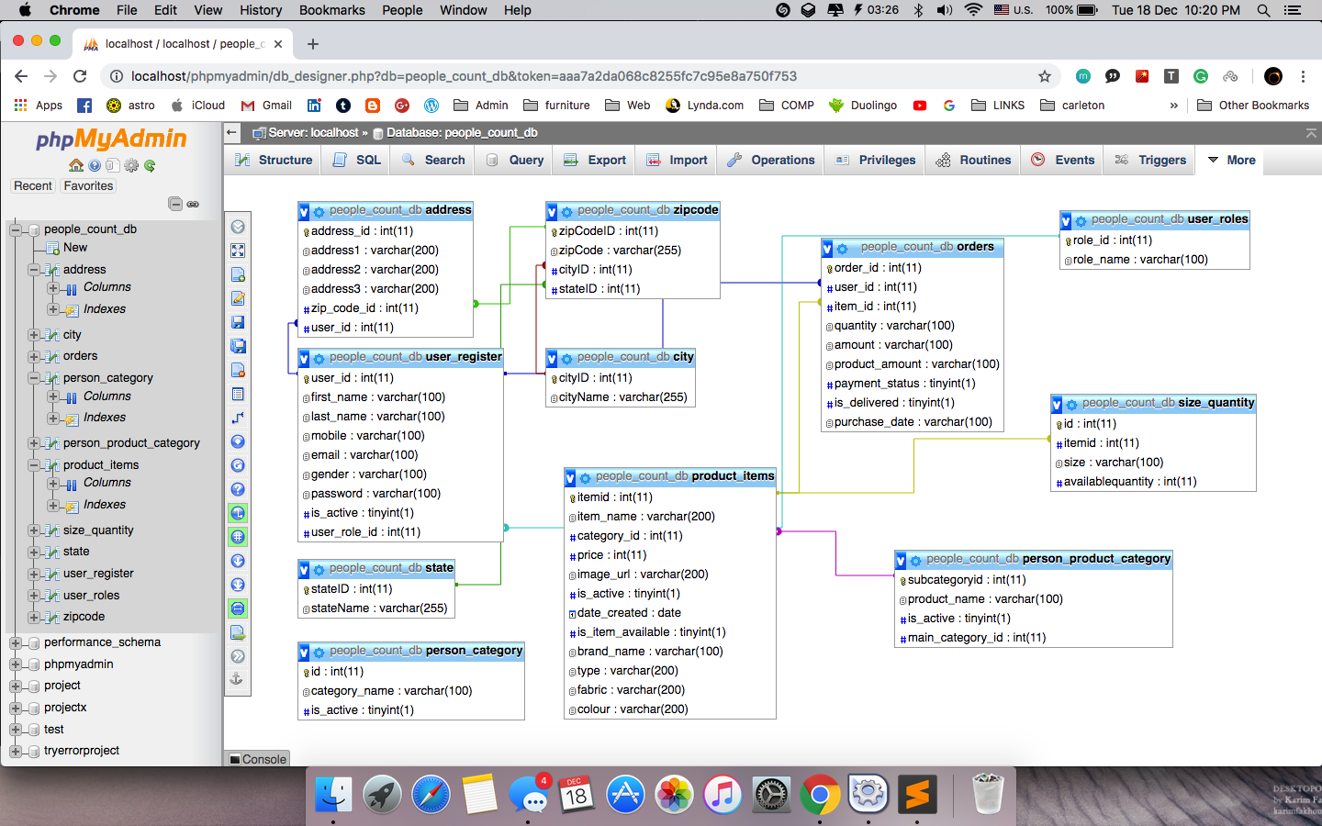

shows a different layout where user selects the option from navigation bar and chooses to select a particular location

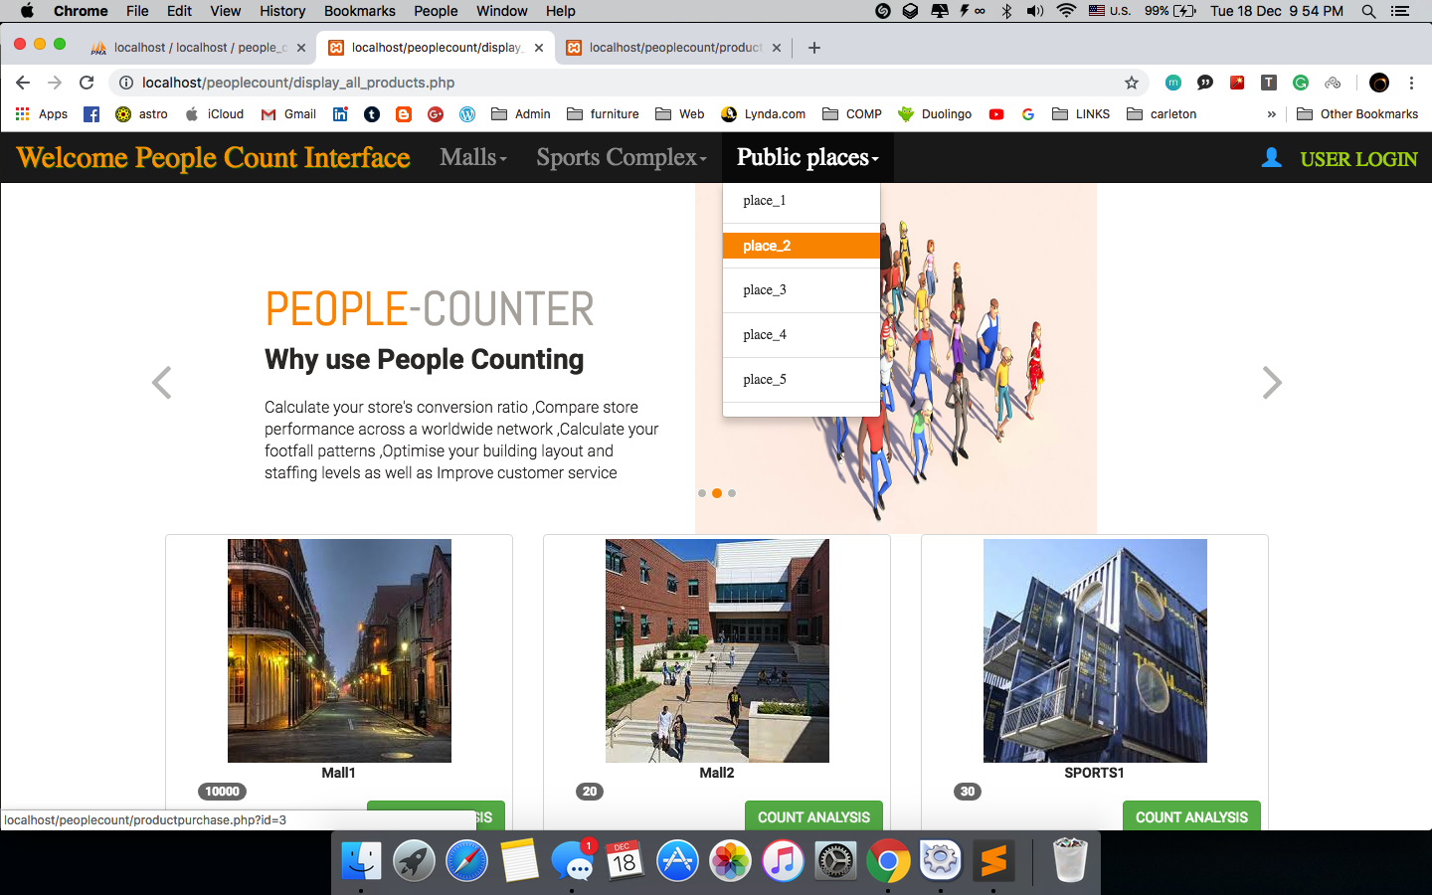

details request form shows the details the user wants to buy or view in real time analyitics performed on the location by People counter technology.

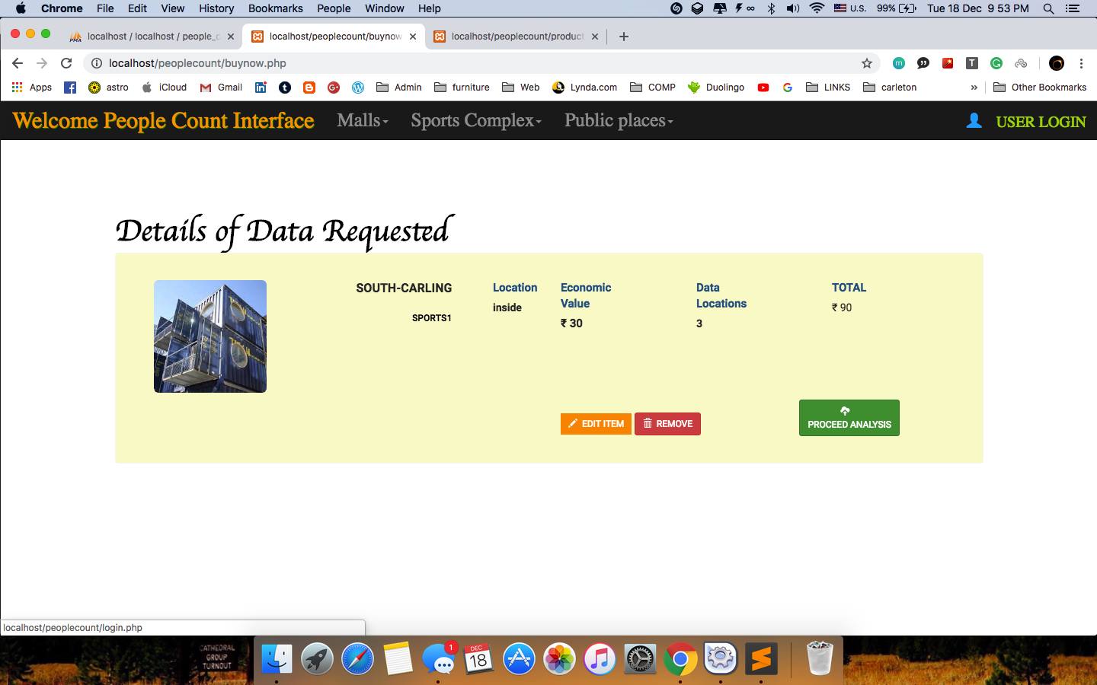

view of details to be confirmed at the checkout for which acknowledgement is made for the user

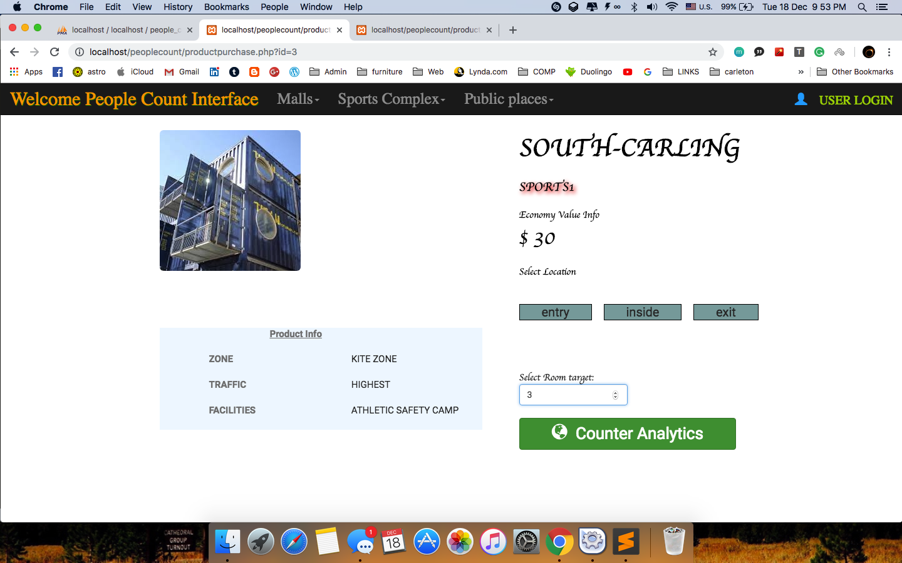

User login page

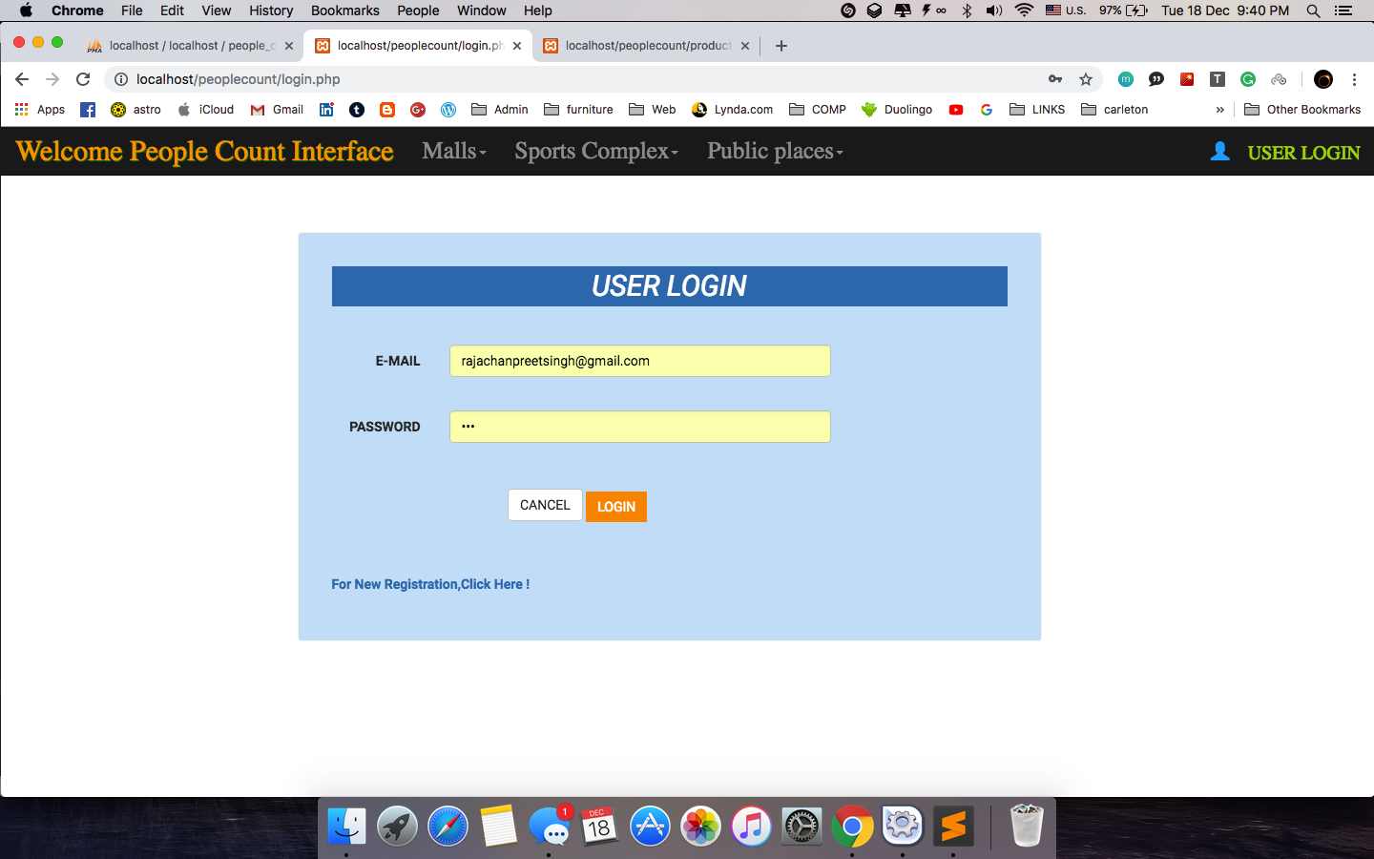

details of shipping

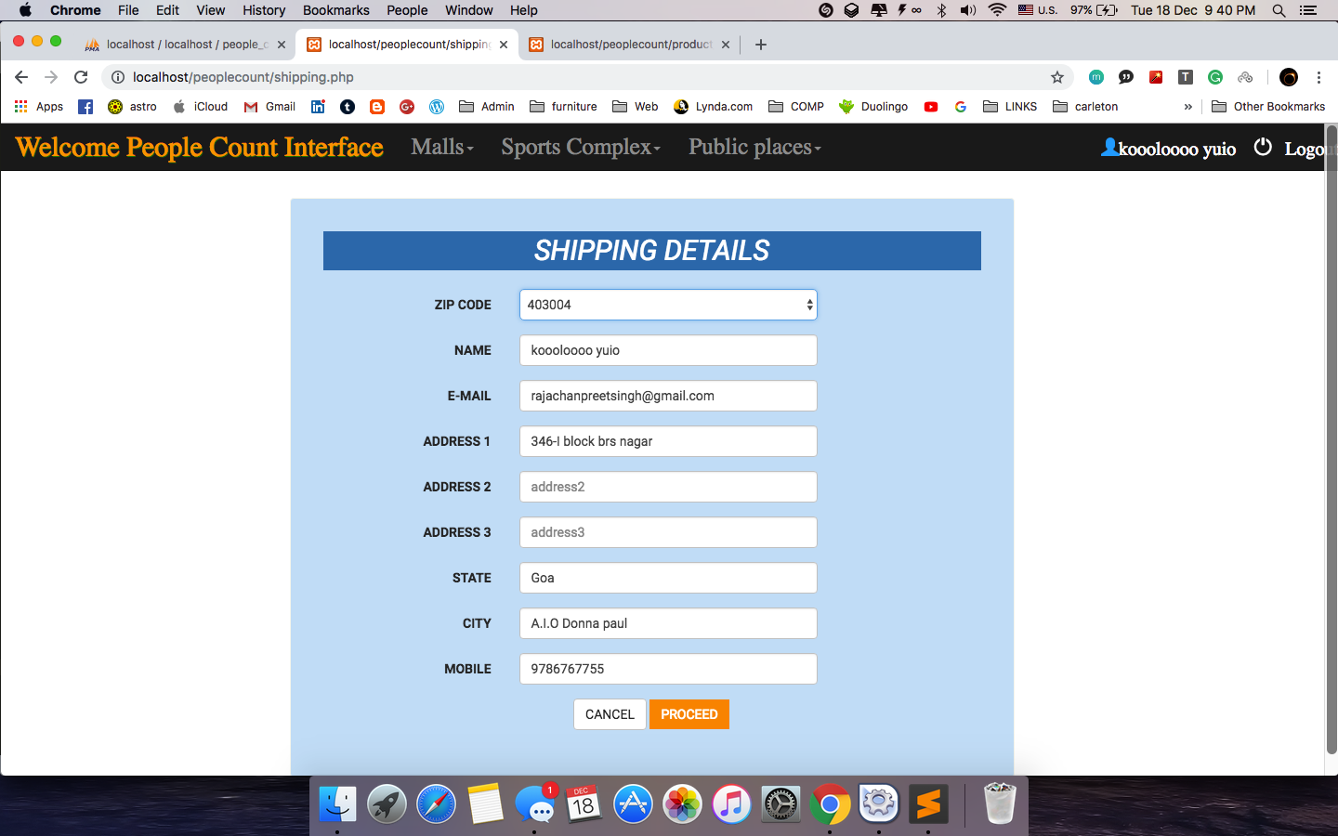

Confirmation of Data Requested after adding the details of shipping

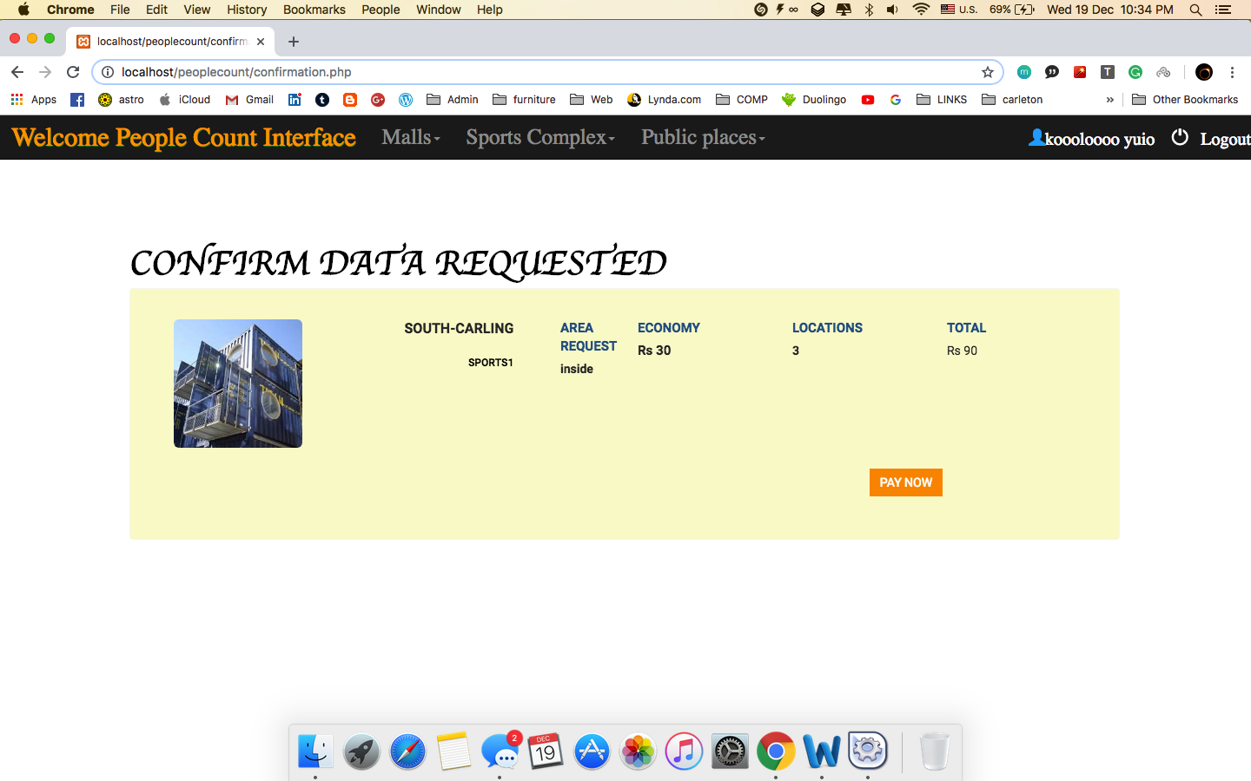

payment page redirected on to paypal sandbox used

